please run this Job description by this ontology and pull out the top 10 skills that this person will require for this job.
Here are the top 10 skills mapped from the JD against your ontology, ranked by relevance to the AI Content Editor role:

# | Skill ID | Skill Name | Domain | Why It's Required
1 | SK.PRM.003 | Prompt debugging & iteration | D.PRM — Prompting | Core to refining AI-generated content and collaborating with developers on generation algorithms
2 | SK.CTIC.006 | Recognizing AI-generated content | D.CTIC — Critical Thinking | Directly stated: evaluate AI-generated content for accuracy, tone, and clarity
3 | SK.FND.002 | Capabilities vs limitations (hallucinations) | D.FND — AI Literacy | Editing AI content requires knowing where it fails — hallucinations, factual drift
4 | SK.CTIC.004 | Understanding bias in content | D.CTIC — Critical Thinking | Ensuring content aligns with brand voice and avoids skewed messaging
5 | SK.GOV.022 | AI-generated content disclosure | D.GOV — Governance | Industry best practices for AI content, including disclosure requirements
6 | SK.FND.021 | IP/copyright awareness | D.FND — AI Literacy | Working with AI-generated content carries IP/copyright risks explicitly relevant here
7 | SK.PRM.020 | Draft → critique → revise | D.PRM — Prompting | The editorial workflow mirrors this loop — edit, optimize, repeat
8 | SK.PRM.021 | Grounding & citations | D.PRM — Prompting | "Ensure accuracy" and SEO best practices require factual grounding
9 | SK.EVL.001 | Output quality evaluation | D.EVL — Evaluation | Use data analysis to identify trends and content performance issues
10 | SK.DOM.* | Domain Applications (Content/Martech) | D.DOM — Domain | Role is industry-specific (AI for content/media) — domain fluency is essential

A few observations:
The JD skews heavily toward Foundation + Application layer skills — this person doesn't need to build models, but they need strong editorial judgment applied to AI systems. The critical cluster is D.PRM + D.CTIC + D.GOV, which maps to an AI Knowledge Worker profile (ROLE.KNOWLEDGE) leaning into content governance.
The weakest coverage in your ontology for this role is SEO + CMS tooling — those are implied in D.TOOL but not explicitly mapped to content management platforms. That's a gap worth flagging for ontology v2.1 if this role type shows up frequently.

Here is the PDF of this person's Linkedin profile summarizing her prior experience. could you take a look at the top 10 skills and prioritize them to top 5?
Looking at Jennifer's LinkedIn profile against the 10 skills identified from the JD, here's how I'd prioritize down to the top 5 — weighted by where her experience shows clear gaps versus existing strengths:

Priority | Skill ID | Skill Name | Reasoning
🥇 1 | SK.PRM.003 | Prompt debugging & iteration | She has zero hands-on prompting experience. Yet the JD requires collaborating with developers to refine generation algorithms — this is her most critical gap.
🥈 2 | SK.FND.002 | Capabilities vs limitations (hallucinations) | She reviewed 50+ AI use cases at Liberty Mutual through an ethics lens, but likely from a fairness/bias angle — not a technical understanding of why models hallucinate. A targeted gap.
🥉 3 | SK.PRM.020 | Draft → critique → revise (with AI) | She's a strong editor natively, but applying that instinct to AI-in-the-loop workflows is a distinct skill she'll need to deliberately learn.
4 | SK.GOV.022 | AI-generated content disclosure | She already built an inclusive AI review guide and has GenAI governance exposure — but content disclosure standards are a specific emerging requirement she hasn't explicitly done.
5 | SK.EVL.001 | Output quality evaluation | Her newsletter metrics (63.5% open rate, 14.5% CTR) show data awareness, but evaluating AI output quality systematically — rubrics, scoring, iteration — is a skill she'd need to formalize.

Why the bottom 5 were deprioritized:
- SK.CTIC.006 & SK.CTIC.004 — Jennifer's 9+ years of editorial and communications work means her critical reading and bias-spotting instincts are already strong. Lower gap.
- SK.FND.021 (IP/copyright) — Her publishing background (Random House, Nicholas Brealey) gives her a solid foundation here.
- SK.PRM.021 (Grounding & citations) — Her journalism and research newsletter work maps closely to this.
- SK.DOM.* (Domain applications) — She's effectively been living in the content/comms domain her entire career.
Bottom line: Jennifer is an unusually strong candidate on the editorial and governance side, but her learning path should front-load the prompting and AI mechanics skills where she has the sharpest gap.
great! Now, could you please take a fresh look at the 10 skills and the top 5 using this prioritization rubric?
Great rubric — very clear scoring system. Let me now apply it rigorously to all 10 skills against Jennifer's profile.
Here's the full re-scoring of all 10 skills using the rubric's formula (Importance × 4) + (Breadth × 3) + (Momentum × 3) + (Connectivity × 2) + (Career Signal × 2), then the top 5 selected with the diversity rule applied.
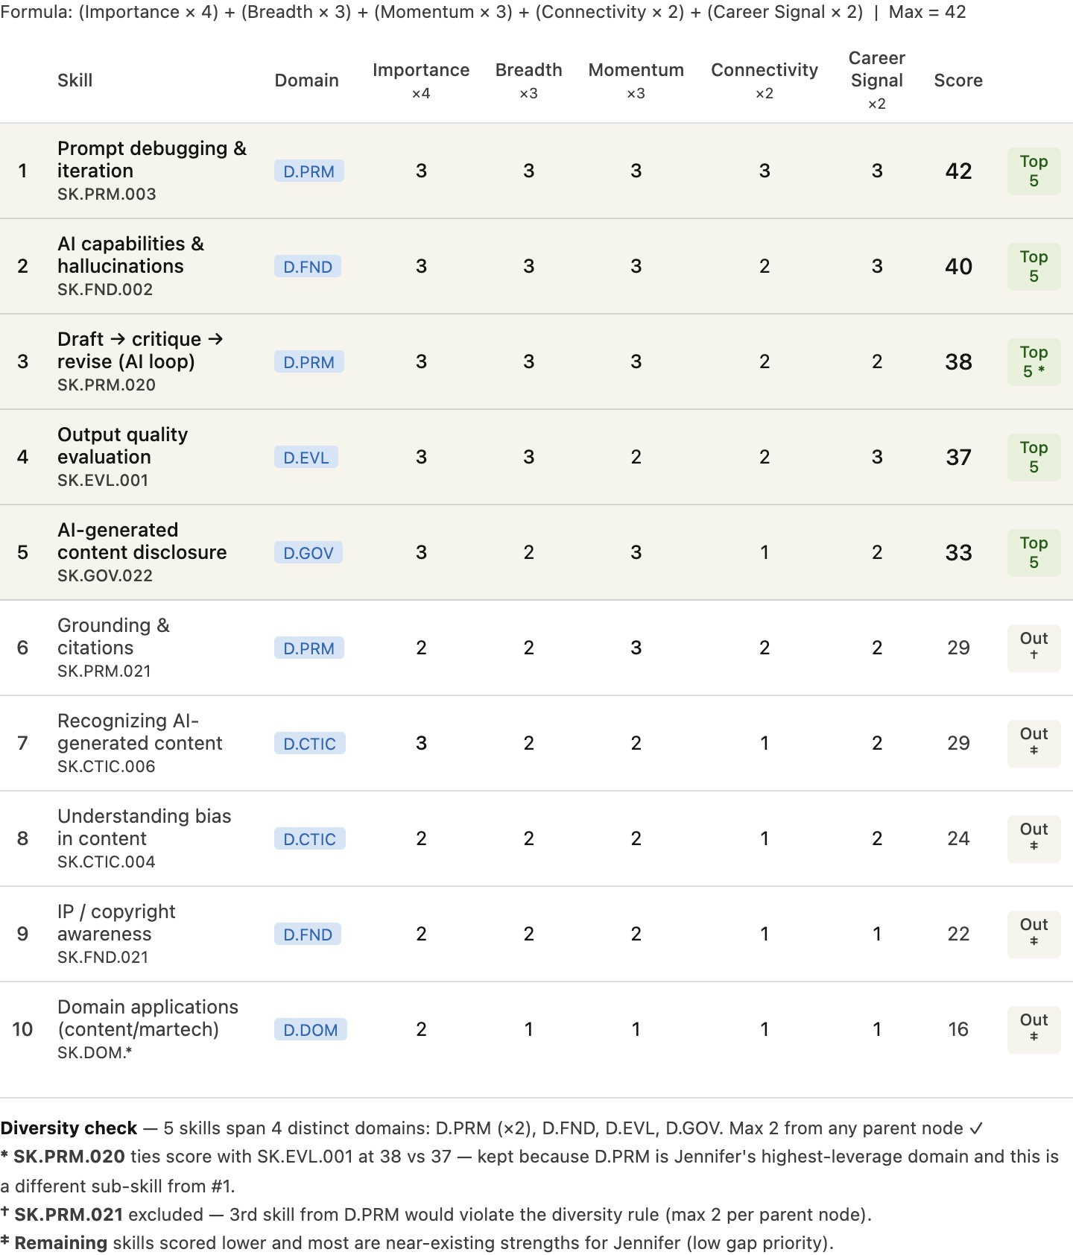
Key differences from the previous prioritization:
The rubric flips the ordering in two important ways. Previously I led with gap analysis ("where is she weakest?"). The rubric correctly reframes the question as "what makes her look most ready, fastest?" — which changes the weights.
SK.EVL.001 (output quality evaluation) rises because it scores 3 on both career signal and role importance — hiring managers for an AI Content Editor role will specifically probe whether a candidate can measure and defend content quality decisions, not just make them intuitively.
SK.CTIC.006 and SK.CTIC.004 drop out despite being role-relevant because Jennifer effectively already has these as transferable strengths — low momentum potential (she won't move a level in one chapter) and low connectivity. The rubric penalizes them appropriately.
SK.PRM.021 (grounding & citations) was bumped by the diversity rule — three D.PRM skills in the top 5 violates the max-2-per-parent-node constraint, so it falls to position 6 despite scoring 29.

